***Virginia Junior Classical League***

*presents this*

Certificate of Excellence

*to*

Ayumi Tsuyuki

*of*

Seneca Ridge Middle School

*for*

*1st Place in Reading Comprehension*

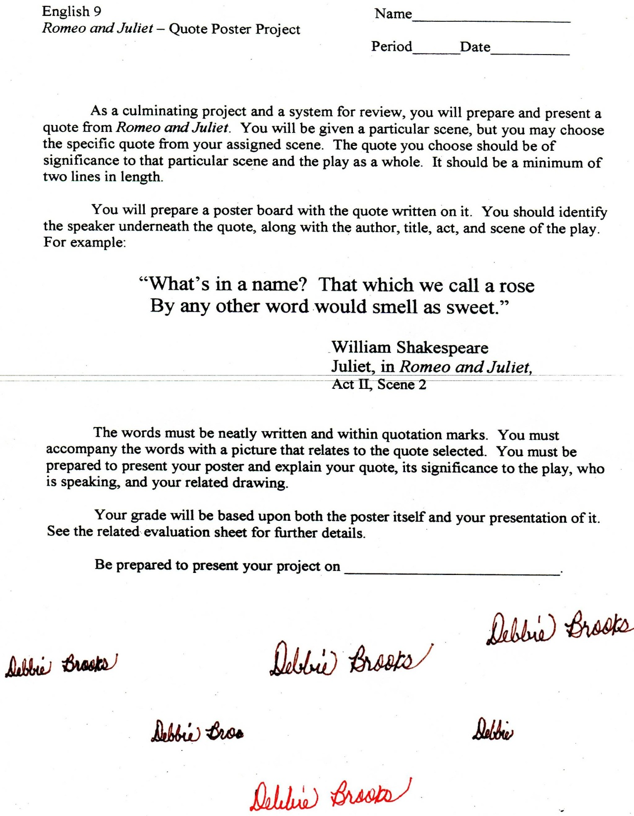

Microsoft Office Signature Line...

*a.d. viii Kal. Dec. MMDCCLXVII A.U.C. 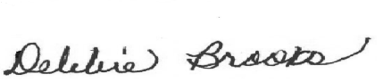*

***Virginia Junior Classical League***

*presents this*

Certificate of Excellence

*to*

Ayumi Tsuyuki

*of*

Seneca Ridge Middle School

*for*

*3rd Place in Grammar*

**

Microsoft Office Signature Line...

*a.d. viii Kal. Dec. MMDCCLXVII A.U.C. *

***Virginia Junior Classical League***

*presents this*

Certificate of Excellence

*to*

Rosanna Fajutrao

*of*

Seneca Ridge Middle School

*for*

*4th Place in Reading Comprehension*

**

Microsoft Office Signature Line...

*a.d. viii Kal. Dec. MMDCCLXVII A.U.C. *

***Virginia Junior Classical League***

*presents this*

Certificate of Excellence

*to*

Seraphim Gustilo

*of*

Seneca Ridge Middle School

*for*

*4th Place in Reading Comprehension*

**

Microsoft Office Signature Line...

*a.d. viii Kal. Dec. MMDCCLXVII A.U.C. *

***Virginia Junior Classical League***

*presents this*

Certificate of Excellence

*to*

Ayumi Tsuyuki

*of*

Seneca Ridge Middle School

*for*

*4th Place in Storytelling*

**

Microsoft Office Signature Line...

*a.d. viii Kal. Dec. MMDCCLXVII A.U.C. *

***Virginia Junior Classical League***

*presents this*

Certificate of Excellence

*to*

Rosanna Fajutrao

*of*

Seneca Ridge Middle School

*for*

*5th Place in Costume - Girls Lower Division*

**

Microsoft Office Signature Line...

*a.d. viii Kal. Dec. MMDCCLXVII A.U.C. *

***Virginia Junior Classical League***

*presents this*

Certificate of Excellence

*to*

Ayumi Tsuyuki

*of*

Seneca Ridge Middle School

*for*

*5th Place in Illustrated Quotations*

**

Microsoft Office Signature Line...

*a.d. viii Kal. Dec. MMDCCLXVII A.U.C. *

***Virginia Junior Classical League***

*presents this*

Certificate of Excellence

*to*

Sophia Truxell-Svenson

*of*

Seneca Ridge Middle School

*for*

*6th Place in Other*

**

Microsoft Office Signature Line...

*a.d. viii Kal. Dec. MMDCCLXVII A.U.C. *

***Virginia Junior Classical League***

*presents this*

Certificate of Excellence

*to*

Sophia Truxell-Svenson

*of*

Seneca Ridge Middle School

*for*

*8th Place in Storytelling*

**

Microsoft Office Signature Line...

*a.d. viii Kal. Dec. MMDCCLXVII A.U.C. *

***Virginia Junior Classical League***

*presents this*

Certificate of Excellence

*to*

Sophia Truxell-Svenson

*of*

Seneca Ridge Middle School

*for*

*9th Place in Reading Comprehension*

**

Microsoft Office Signature Line...

*a.d. viii Kal. Dec. MMDCCLXVII A.U.C. *